27U ENCLOSURE 19" CABINET 600X1000 FLOOR STANDING SERVER RACK - ECO NETCAB
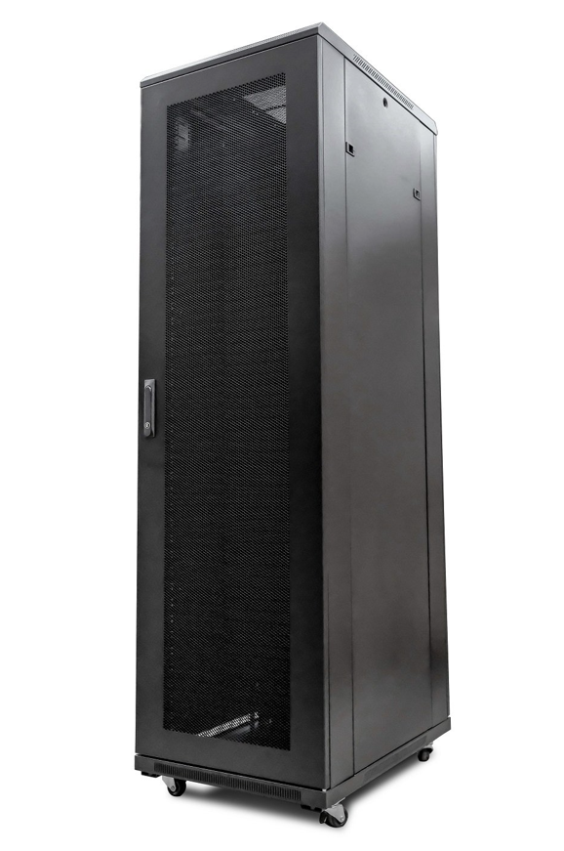

DESCRIPTION
Redefining quality ergonomics for your server and networking needs
Looking to house your rack-mount server, SAN, UPS or other networking
devices?
Rack-mount servers and computers are becoming more popular in all sizes of
business, both public and private sector. LMS Data are market leaders in provide
high-quality, best-in-class ergonomics and security for all your server, networking
and broadcasting needs and the new EcoNetCab server range continues this
tradition.
Offering a range of class-leading heights, ideal from the smallest IT closet
up to large-scale enterprise and data centres with the option for secure access,
co-containment and multiple door option fitments, the LMS Data EcoNetCab is your
ideal partner for your server, SAN and rack-mount UPS containment.

SPECIFICATIONS
- ETSI 19” front/rear profiles, adjustable
- 800Kg static load bearing
- Front mesh high venting door(lockable)
- Left or right hinged front/rear doors
- Removable side panels for easy access
- U-numbered uprights for alignment
- Multiple cable entry gland plates
- Powder-coated RAL 9005

TECHNICAL INFO
SKU/MPN: CAB-FE-27U-6100
EAN: 8400800015983
Weight: 100kg
Dimensions: 600x1000x1370mm

FILES
Datasheet - CAB-FE-27U-6100

